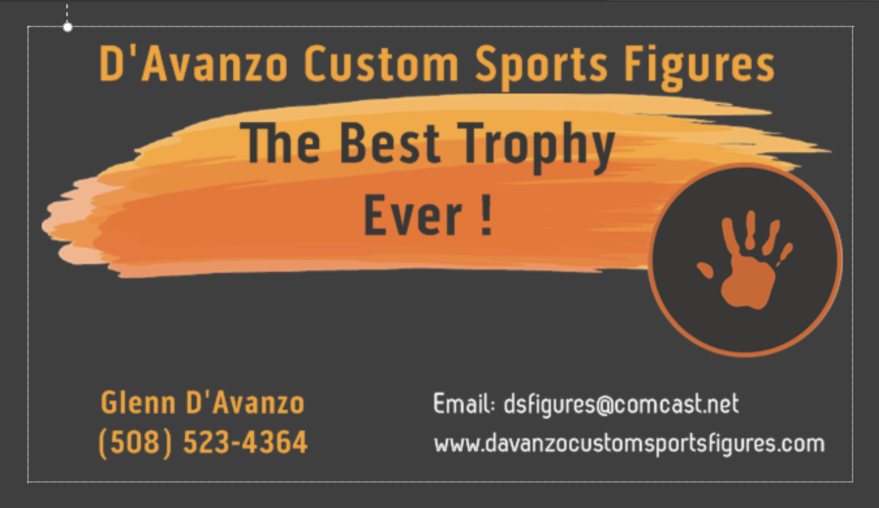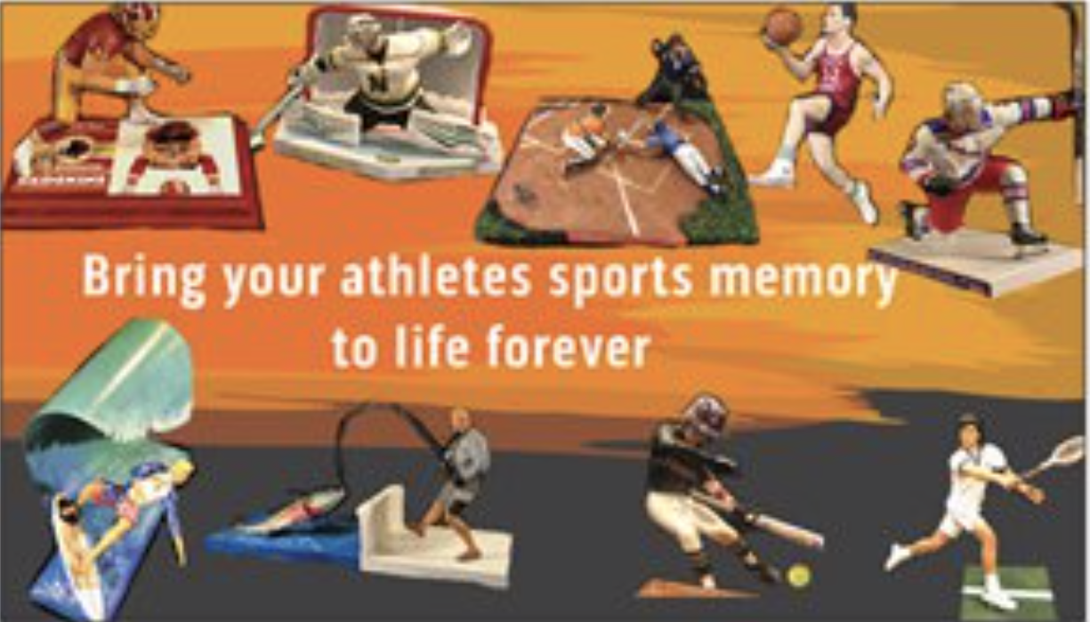
Website: https://www.davanzocustomsportsfigures.com/

Custom Information Sheet:

Athlete’s Name: First____________________ Last_________________________
Sport: ________________________
Position for custom figure (ex; hitting, shooting..) OR EMAIL PHOTOS TO mailto:dsfigures@comcast.net ________________________
TOWN &Team name: ________________________
Year(s) ________________________
Jersey #: _____________________

Athlete’s stature or height & weight in playing time (describe as needed)

Hair color: ________________________
Eye Color: ________________________
Skin tone:________________________

Equipment Details (Make & model, color etc) Ex, Wilson A2000 glove, tan
Shirt:____________________________________
Pants/ shorts: ____________________________________
Belt: ____________________________________
Sneaker/ Cleats/ Skates: ____________________________________
Socks: ____________________________________
Glove (s) (hockey, baseball) ____________________________________
Batting or catching gloves (baseball, football) ____________________________________
Hat/ helmet; ____________________________________
Bat/Stick:____________________________________
Other (describe as needed):

Provide as many pictures as you feel is needed. Email photos and form to: mailto:dsfigures@comcast.net

